Go to Coresetups>>Establishment post setups>>Post definition>>Assistant Manager>> Regional Head Retail Sales PH>> change the category here to Non Life

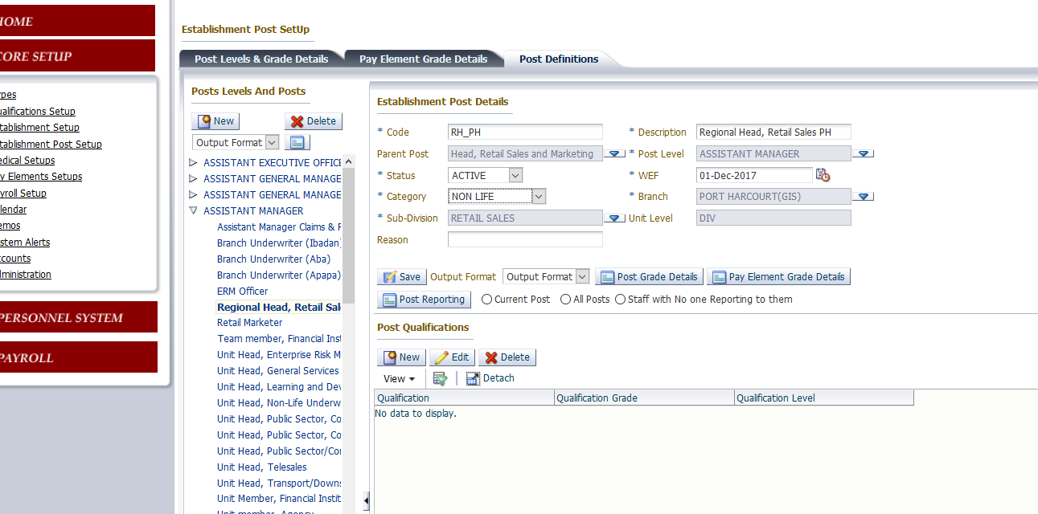

Go to Coresetups>>Establishment post setups>>Post definition>>Manager>Regional Head Retail sale Abuja>> change the category here to Non Life

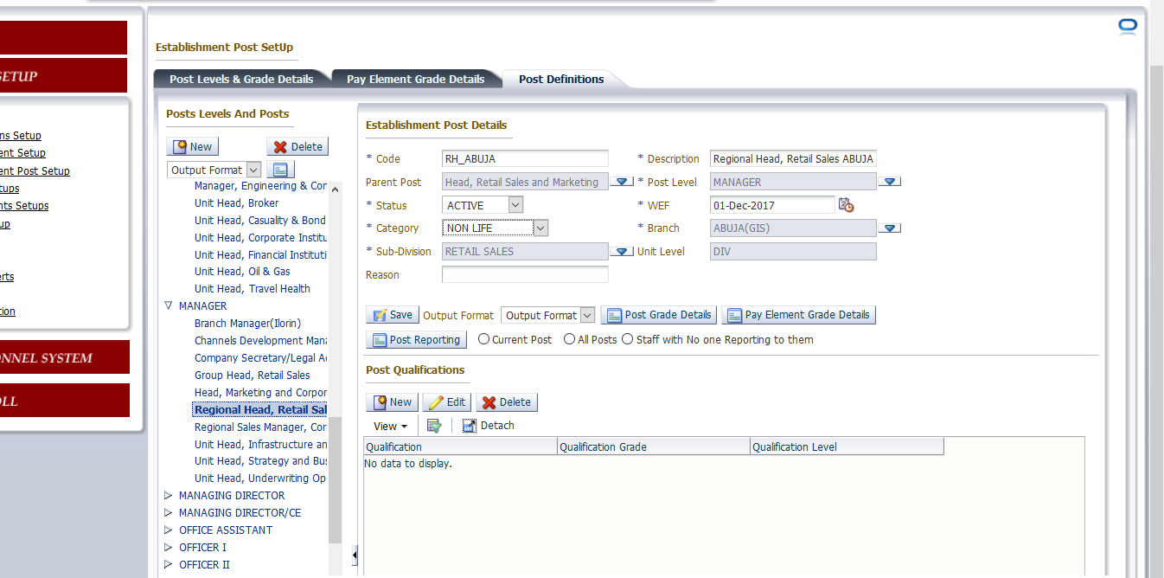

Go to core setups>>Accounts>>General Ledger interface for branch Abuja LMS>> We have two mappings for Basic Pay . Remove the 2018 one.

